**Cybersecurity 401**

**Module 9 - Pentesting**

**__________________________________________**

## **Lab 41 - Reconnaissance with Maltego**

## 

## 

**| Rodrigo Brasil 01/2024 |**

### **Part 1: Staging**

**This lab requires a Kali VM.**

**If you have not yet done so, create accounts on the following sites in order to use their public APIs:**

* [**VirusTotal**](https://www.virustotal.com/)

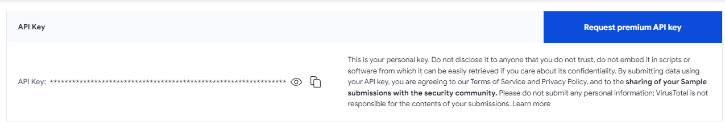

* [**Hybrid Analysis**](https://www.hybrid-analysis.com/)

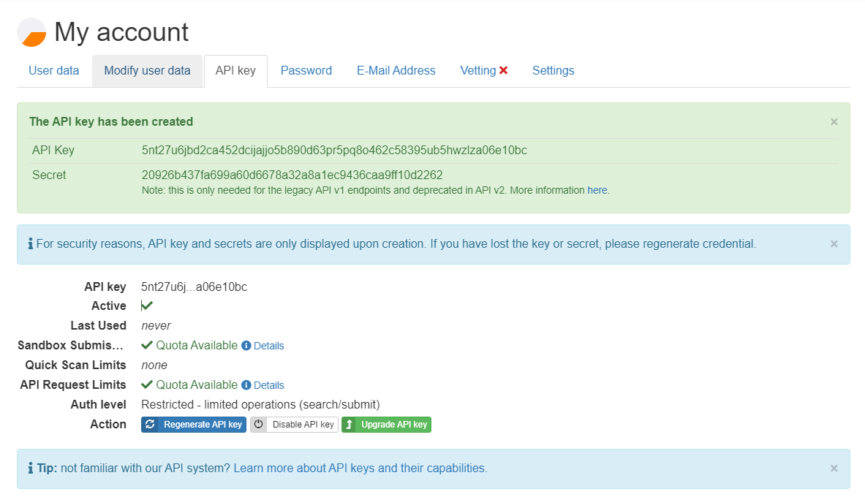

***This are temporary accounts made with tempmail and a random password***

### 

### **Part 2: Profiling an APT Group**

**While known for its investigatory powers, Maltego is not strictly an offensive pentesting tool. It can also be used to profile an APT in order for your organization to defend against that APT’s TTPs. Resources like** [**Fire Eye’s APT Group List**](https://www.fireeye.com/current-threats/apt-groups.html) **keep track of the most notorious active APTs. While you’re more likely to be hit by the everyday phishing scam than an international APT, you’ll want to know about these if you end up working for a major well-known enterprise.**

* **Download the threat report for APT41.**

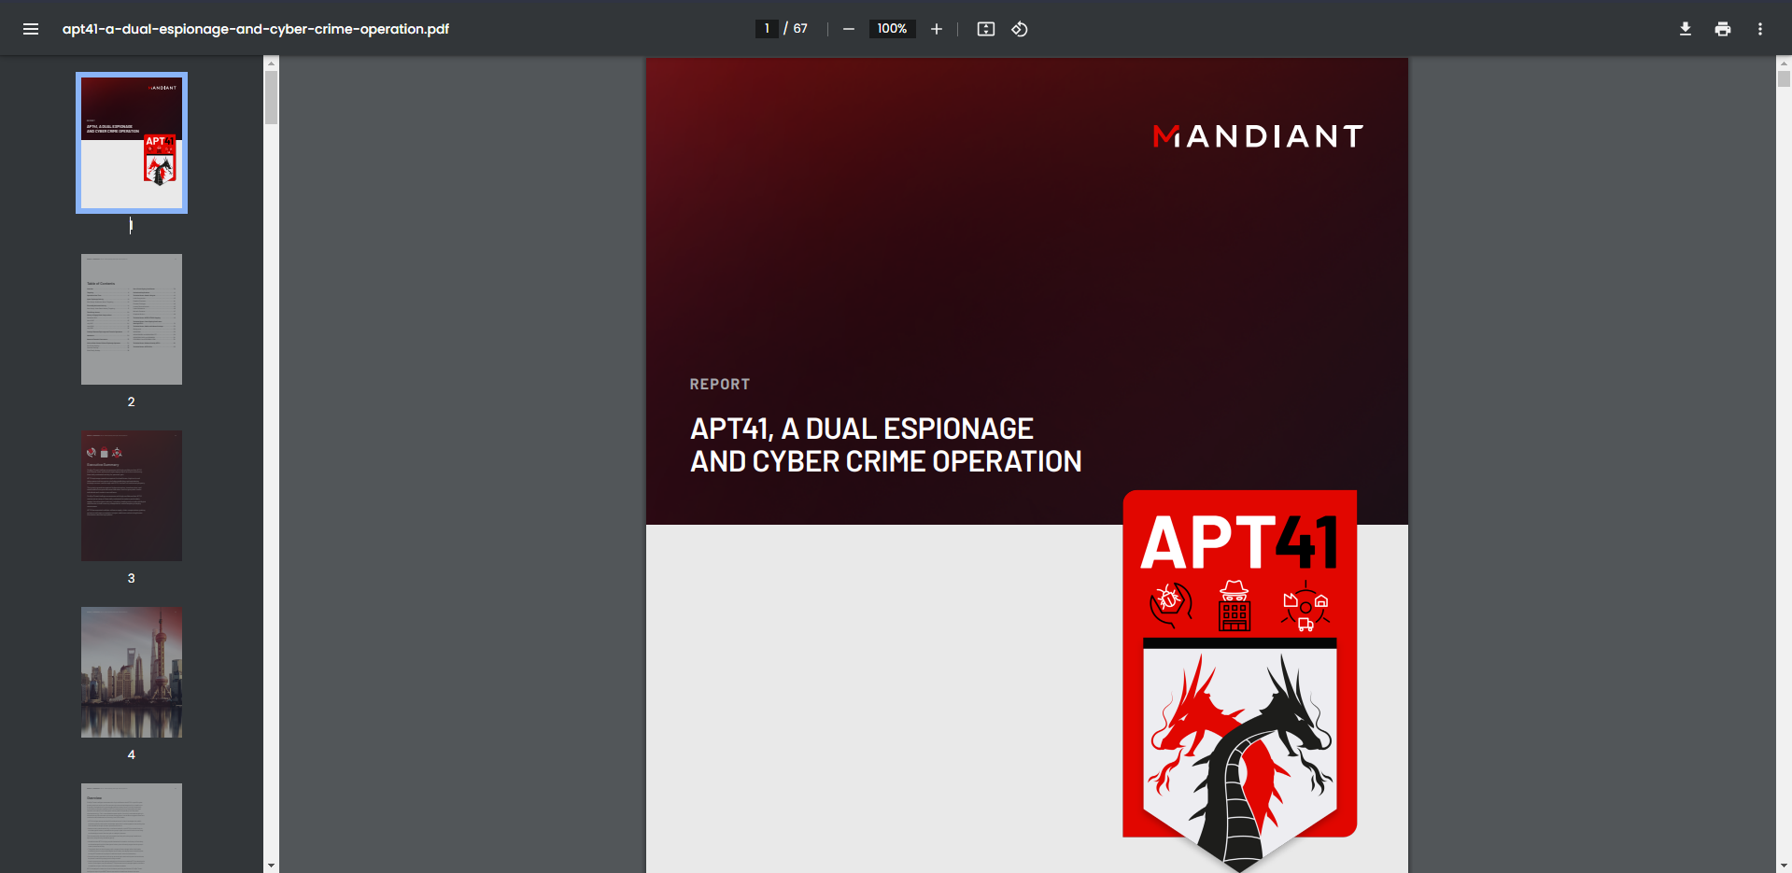

* **Generally speaking, what TTPs does APT41 use (e.g. “lateral movement”)?**
  + Targeted Spear Phishing
  + Supply Chain Attacks
  + Zero-Day Exploits
  + Custom Malware
* **Identify and discuss at least one signature TTP, hash, or domain used by APT41. How can this knowledge help us protect against APT41?**
  + www[.]mlcrosoft[.]site
  + We can blacklist the domain so if any user accidentally clicks on a link with this domain it won't be able to access it

***“TA505 is a financially motivated threat group that has been active since at least 2014. The group is known for frequently changing malware and driving global trends in criminal malware distribution.” -MITRE ATT&CK®***

**Let’s start with investigating the TA505 threat actor group and see what we can do to protect our organization against them.**

* **Use VirusTotal transformations to identify IP addresses associated with the following domains:**
  + Filesharess[.]com

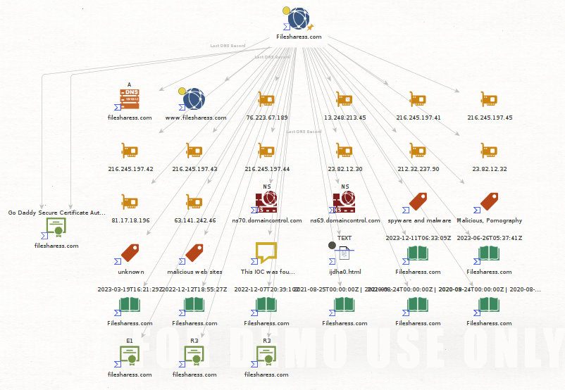

* + Live-en[.]com

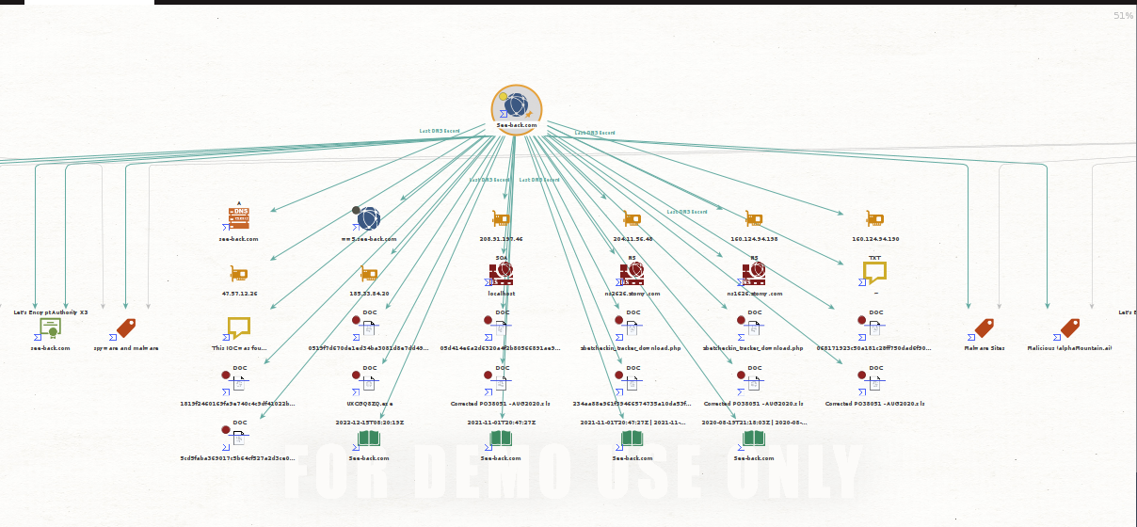

* + See-back[.]com

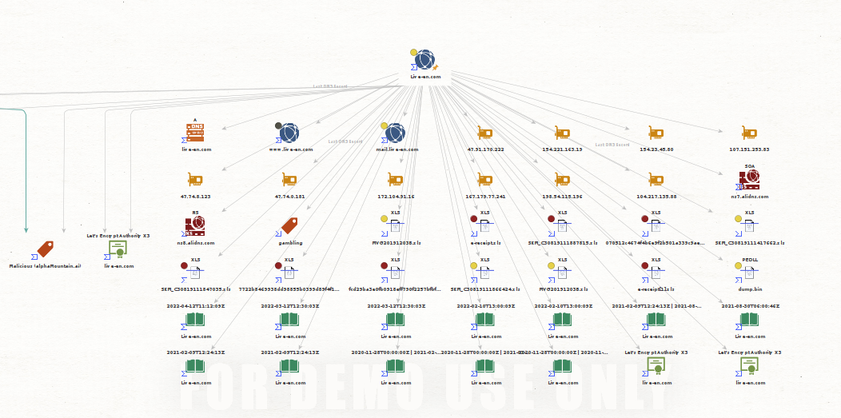

* **Include a screenshot of the resulting graph in your submission.**

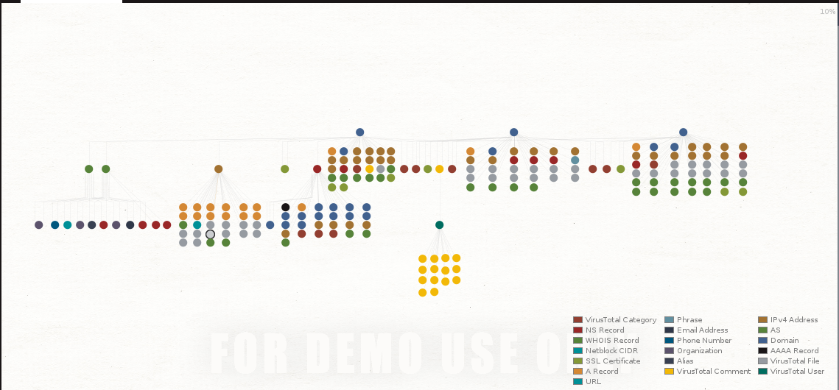

* **What can your organization do to defend its networks and users against these known malicious IP addresses? Name at least one specific tool or system you’d use.**
  + Implement TIP (Threat Intelligence Platform) This tool aggregates, correlates, and analyzes threat data from various sources, including known malicious IP addresses.

**Next, let’s identify the hashes of known IOCs affiliated with these TA505 domains.**

* **Use Hybrid Analysis “Query Domain” transformation to identify the hashes and URLs of known IOCs associated with these malicious domains.**
* **Include this screenshot in your submission.**

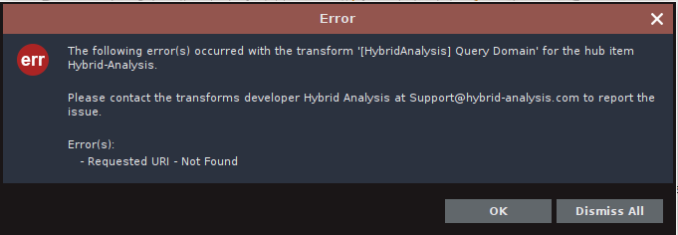

* **Upload a hash to VirusTotal. Did this result in a positive?**

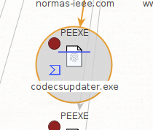

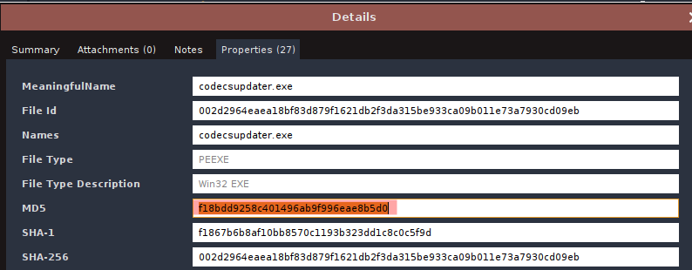

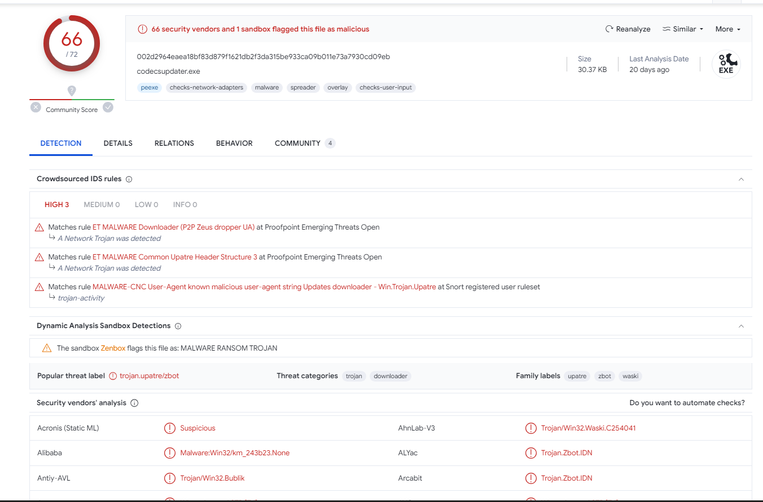

* **Why or why not might an IOC hash result in a positive on VirusTotal?**

If the hash corresponds to a known malware sample with existing signatures in these databases, it will likely result in a positive detection. If the file is new or unknown, antivirus engines may not have specific signatures for it, leading to a negative detection.

* **What can your organization do to defend its networks and users against these known malicious artifacts? Name at least one specific tool or system you’d use.**

Implement a IDS (Intrusion Detection System) to monitor network traffic for suspicious patterns or known indicators of compromise (IOCs). It will then generate alerts when potential threats are detected.

***Be careful not to accidentally browse to these malicious sites.***

**The Maltego transform, “To Snapshots [Wayback Machine],” can help you trace back the source of the threat.**

* **Execute To Snapshots [Wayback Machine] Transform against the three malicious domains and include screenshots of the results.**

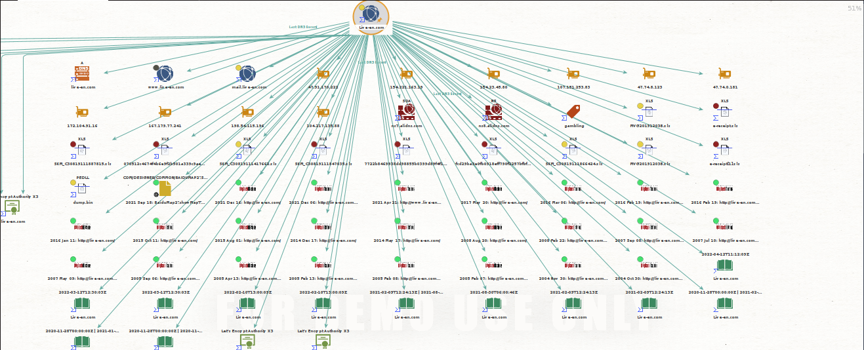

* **What are these results?**
  + This results shown are all the snapshots taken from the domain using the wayback machine transform
* **What do these results tell us about TA505?**
  + Tell us that the domain was active and used very recently

### 

### **Part 3: Profiling a Company with Maltego Transforms and Machines**

**Maltego can be used to research a target organization to learn more about it in advance of an attack, such as a pentest.**

* **Identify the MX record associated with myspace.com.**

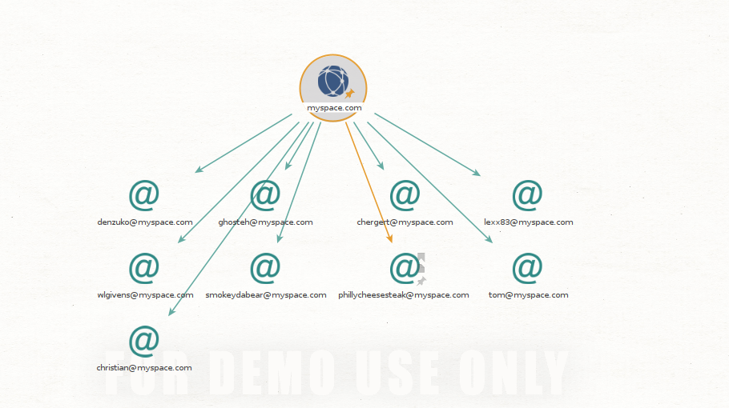

* **What is an MX record, and how does it affect mail server traffic for the domain, myspace.com?**
  + MX (Mail Exchange) records are DNS (Domain Name System) records that specify the mail servers responsible for receiving email messages on behalf of a domain.
* **If we wanted to disrupt the company’s mail server traffic, how could this information be useful to us as an attacker performing recon?**
  + sd

**DNS can tell us a lot about a company, if the WHOIS records are not obfuscated by the domain owner.**

* **Identify the email address(es) of the domain’s owner.**

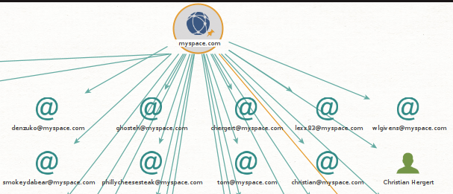

* **Identify the phone number(s) of the domain’s owner.**

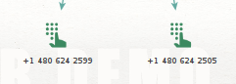

* **Where does the domain owner live? Include a screenshot of their Myspace page.**

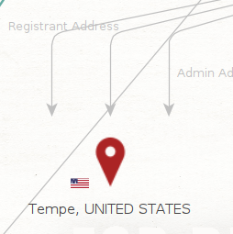

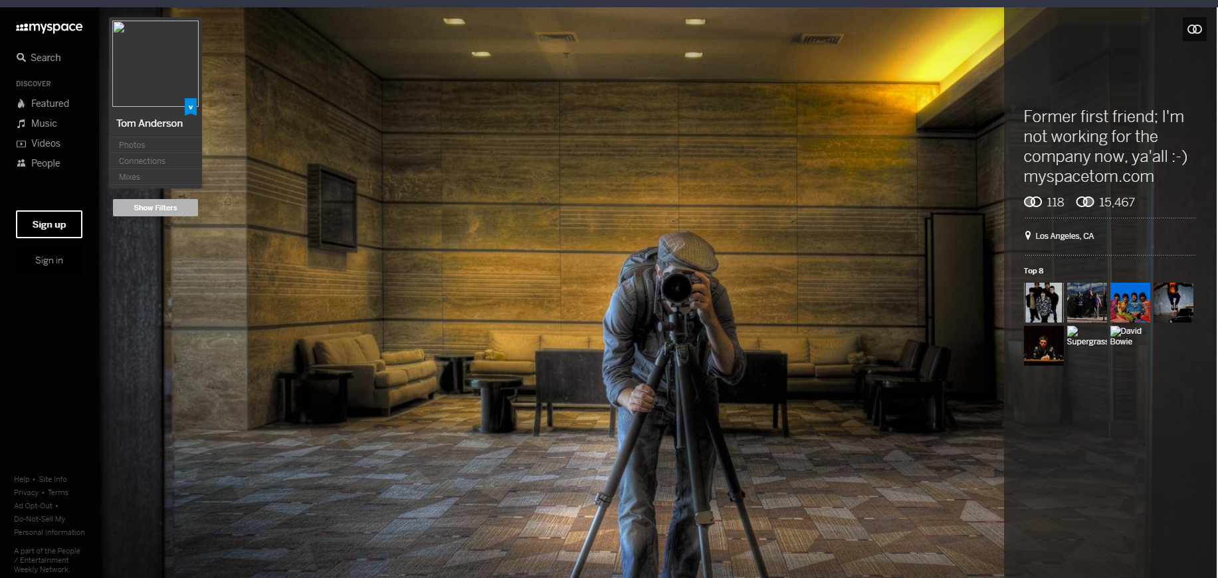

* **How can this information be used by an attacker?**

**This information could for example find out who this person is, impersonate them**

**The “Machines” in Maltego perform automated investigations for us.**

* **Use the “Company Stalker” Machine against myspace.com.**



* **What was returned on the graph?**

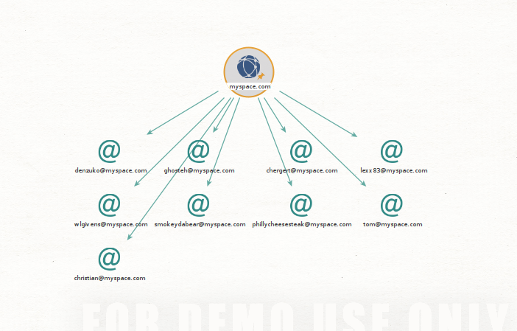

* **Explain how Maltego was able to retrieve this information using the Company Stalker Machine. In other words, what does the Company Stalker Machine do?**
  + This machine will try to get all email addresses at a domain then see which resolves on social networks. It also gets documents and extracts metadata.
* **Pull up the Myspace page for one of the email addresses on the graph and include a screenshot of it (keep it work-appropriate!).**

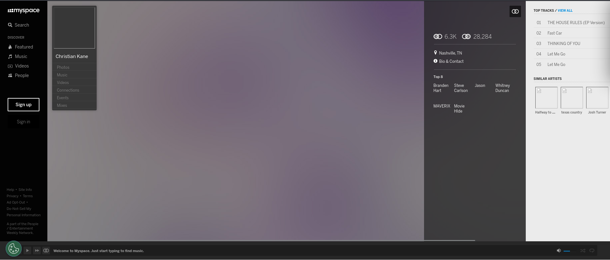

**Next, let’s try to find associated web entities to myspace.com.**

* **Using Machines, perform a Level 1 Footprint against the domain, myspace.com.**
* **Include a screenshot of the results. What did this return?**

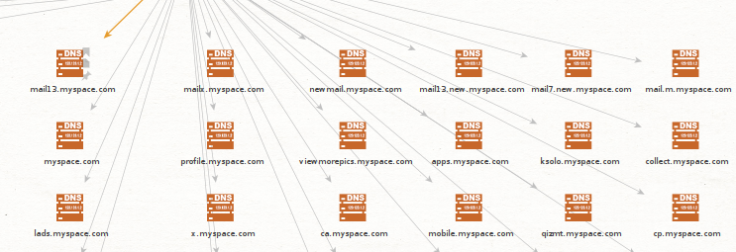

* **Identify the mail servers associated with myspace.com. How did Maltego determine this relationship? (Hint: How does the internet work?)**
* **Identify cities associated with the results. Why is Maltego displaying cities? (Hint: How does IP addressing work?)**

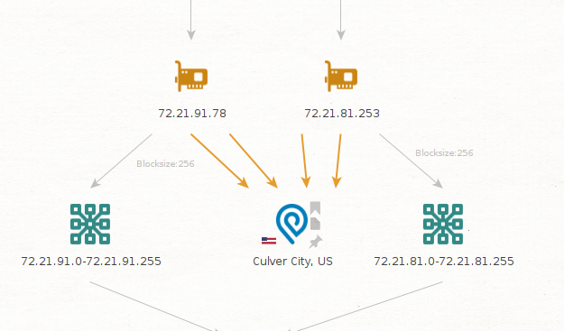

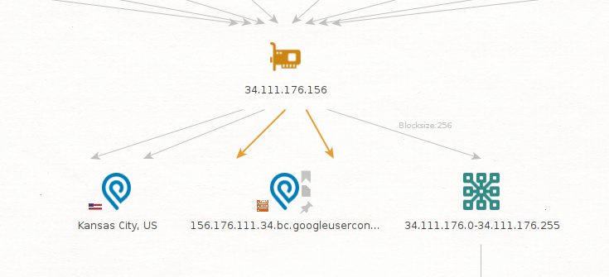

### 

### **Part 4: Reporting**

**Using the myspace.com Level 1 Footprint graph, generate a Maltego PDF report, upload it to your Google Drive, then link to it in your submission**

[myspace.pdf](https://drive.google.com/file/d/1YVFlS6fhysGLLjLTLsTw65WTEjTuYUBk/view?usp=drive_link)